Student Name
Mathematics Stage 5 Core
Financial
Mathematics A

Book 1 | Solve problems involving earning money | Version: 260203  Report mistakes & suggest improvements:  https://MrDingMaths.com

Contents
Overview 2
Units of Time 3
Wages 4
Penalty Rates 12
Piecework 21
Royalties and Commissions 24
Salary 30
Bonuses and Allowances 37
Leave Loading 40
Taxable Income 45
Income Tax Table 48
Pay as You Go 57
Tax Refund or Liability 59
Medicare Levy 64

Overview

Syllabus Content
MA5-FIN-C-01 solves financial problems involving simple interest, earning money and spending money
Solve problems involving earning money
- Solve problems involving wages given an hourly rate of pay including penalty rates for overtime, weekends and public holidays
- Calculate earnings from non-wage sources exploring commission, piece work and royalties
- Calculate weekly, fortnightly, monthly and yearly earnings assuming 1 year = 52 weeks
- Calculate leave loading by finding a percentage of eligible normal pay
- Investigate sources of published tables or online calculators and use these to calculate the weekly, fortnightly or monthly tax to be deducted from a worker’s pay under the Australian Pay-As-You-Go (PAYG) taxation system
- Determine annual taxable income by exploring allowable deductions and current tax rates
- Calculate net earnings after deductions and taxation

Units of Time
- 1 year = 12 months (per annum p.a. means per year)
= 52 weeks
= 26 fortnights
- When converting to a larger unit, we divide, since we will need fewer units.
- When converting to a smaller unit, we multiply, since we will need more units.
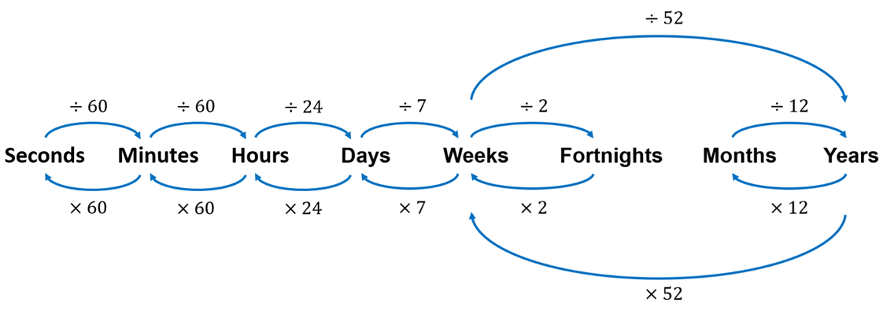

- Note that these are close estimates;
A non-leap year has 365 days, but 52 weeks would only have 364 days.
- A common misconception is treating four weeks as a month.
This is not true. Four weeks is 28 days. Only February has 28 days.

Foundation
- Round answers to 2 d.p. as appropriate.
- Convert 3 weeks to days.  $3×7=$ ……………  21 | - Convert a fortnight to days.  14
- Convert a year to months.  12 | - Convert 2 months to weeks.  $$8.67$$
- Convert 5 years to months.  60 | - Convert a year to weeks.  52
- Convert 18 fortnights to days.  252 | - Convert 9 months to years.  0.75
- Convert 3 years to weeks.  156 | - Convert 8 weeks to days.  56
- Convert 4 weeks to fortnights.  2 | - Convert 3 fortnights to weeks.  6
- Convert 2 years to weeks.  104 | - Convert 8 weeks to fortnights.  4

Wages
- Wages are hourly payments for work.
- Employers usually pay wages weekly or fortnightly.
- When Mr Ding worked at McDonalds, he earned a wage of $12 per hour.
His fortnightly pay depended on his hours worked.
- For wages, how much you earn varies based on how much you work.
You can earn more if you work more hours, but fewer shifts or taking leave reduces your pay.
Calculating Total Pay
$$Total Pay=Pay per period×Number of periods$$

Example Calculate total pay given wage rate and hours.
Mr Ding earned $30 an hour as a mathematics tutor. How much would he earn from a 5-hour lesson?  $$Total Pay=Pay per Period×Number of Periods \\ =\$30/hour×5 hours \\ =\$150$$ | Julie works as a chef for $22 an hour.  How much would she earn in a fortnight if she works 35 hours per week?  $$Total Pay=Pay per Period×Number of Periods \\ =\$22/hour×(35 hours×2) \\ =\$1540$$

- Find the weekly pay if Jason earns $21/hr and works a 38-hour week.  $798 | - Jessie earns $27/h for a 40-hour week. How much would she get paid in 3 weeks?  $3240
- Thomas gets paid $13.95/h for an 8-hour week. How much would he get paid in a fortnight?  $223.20 | - Laura works part time for $25/h and works 20 hours per week. How much would she earn in 1 year?  $26 000

Calculating Pay Rate
$$Pay per period=\frac{Total pay}{Number of periods}$$

Example Calculate hourly pay given total pay and number of hours.
Ella works a 35-hour week as a waitress and is paid $834.75 total.  What is her hourly rate of pay?  $$Pay per period=\frac{Total pay}{Number of periods} \\ =\frac{\$834.75}{35 hours} \\ =\$23.85/h$$ | Jenny is paid $115 000 per year.  If she works 55 hours per week, how much is this per hour? Use 1 year = 52 weeks.  $$Pay per period=\frac{Total pay}{Number of periods} \\ =\frac{\$115000}{55×52 hours} \\ =\$40.21/h$$

- Tyrion worked 17 hours and earned $328.10. Find his hourly wage rate.  $19.30/h | - Abigaile worked 29 hours and earned $700.07. Find her hourly wage rate.  $24.14/h
- Seb earned $3078 over 3 weeks. Each week he works 38 hours. How much does he get paid per hour?  $27/h | - Chloe earned $2349.60 this fortnight. She works 40 hours per week. What is her hourly wage rate?  $29.37/h

Calculating Number of Periods
$$Number of periods=\frac{Total pay}{Pay per period}$$

Example Calculate number of periods given total pay and wage rate.
When Mr Ding worked at McDonald’s, he was paid $9.48 an hour.  How long would it take for him to buy a PS4 costing $510?  $$Number of periods=\frac{Total pay}{Pay per period} \\ =\frac{\$510}{\$9.48/hr} \\ =53.8 hours$$ | Jess earns $16.50/hour. If she earned $387.75 this week, how many hours did she work this week?  $$Number of periods=\frac{Total pay}{Pay per period} \\ =\frac{\$387.75}{\$16.50/hr} \\ =23.5 hours$$

- Simon earns $21.45/hr. How long would it take him to earn enough to buy a laptop costing $2000?  93.24 hours | - Gemma earns $24.95 an hour. If she earned $798.40 for the week, calculate how many hours she worked.  32 hours
- Bertie earns $35.65/hr. How long would it take him to earn enough to buy a phone costing $1800?  If he works 6 hours per week, how many weeks would this take?  8.415 weeks | - Cathy earns $60/hr.  How many weeks would it take her to earn enough for $2400, if she works 4.5 hours per week?  $8.\dot{8}$ weeks
Key ideas
- Income is ……………… that you receive.
- A wage is a type of income where you are paid a fixed amount per ………
- To find total pay, use $Total pay=$ …………………… $×$ ………………………
- To find pay per period, use $Pay per Period=$
- To find number of periods, use $Number of Periods=$

Foundation
- Ariel earns $45.70 an hour. How much does she earn for:
- 8 hours  $$Total Pay=Number of Periods×Pay per Period$$  $=8×45.70$  $=$ ………………  $365.60 | - 40 hours  $1828

- Find the total weekly pay, given the hourly wage and number of hours per week.
- $23/h for a 38-hour week.  $874 | - $19/hr for a 32-hour week.  $608
- $17.17 for a 41-hour week.  $704.37 | - $13.95 for an 8-hour week.  $111.60
- $17.80 for an 18-hour week.  $320.40 | - $38.17 for a 38-hour week.  $1450.46

- Find the pay in these scenarios.
- $19.35/h, 7 hours/day, 5 days/week.  Find weekly pay.  $$Total Pay=Number of Periods×Pay per Period$$  $=(7×5)×19.35$  $=$ ………………  $677.25 | - $23.15/h, 7 hours/day, 5 days/week.  Find weekly pay.  $810.25
- $32.60/h, 38 hours/week  Find fortnightly pay.  $2477.60 | - $54.10/h, 40 hours/week.  Find fortnightly pay.  $4328
- $29.55/h, 18 hours/week  Find fortnightly pay.  $1063.80 | - $19.26/h, 25 hours/week.  Find fortnightly pay.  $963

- Find the hourly rate by dividing the total pay by the number of hours worked.
- $790 for a 25-hour week.  $$Pay per period=\frac{Total pay}{Number of periods} \\ =\frac{790}{25}$$ $=$ ………………  $31.60/h | - $456.30 for a 26-hour week.  $17.55/h
- $340 for a 5-hour week.  $68/h | - $1512 for a 35-hour week.  $43.20/h
- Find the number of hours worked by dividing the total pay by the wage rate.
- $798.40 at $24.95/h.  $$Number of periods=\frac{Total pay}{Pay per period} \\ =\frac{798.40}{24.95}$$ $=$ ………………  32 hours | - $729.30 at $21.45/h.  34 hours
- $625.60 at $19.55/h.  32 hours | - $805.60 at $21.20/hr  38 hours

  - Ted works 38 hours a week and is paid $15.25 per hour. Work out his weekly pay.

$579.50
  - Anne works 13 hours a week and is paid $31.20 per hour. Work out her weekly pay.

$405.60

- Remi earns $28.20 per hour. He works 7 hours one day and 5 hours the next.
  - Find the total hours worked.

12
  - Find his pay over these two days.
$338.40

Development
- Jessie earns $37.35 per hour. She works 7 hours per day, and 4 days in a week.
  - Find how many hours she works in total over a week.
28
  - Find her total weekly pay.

$1045.80

- Ellen earns $43.85 per hour while Ben earns $27.90 per hour. If both work a 38-hour week, find:
  - Ellen’s weekly pay.
$1666.30
  - Ben’s weekly pay.
$1060.20
  - The difference in their weekly pay.

$606.10
- Travis earns $28.63/h while Louis earns $31.55/h. If both work a 20-hour week, find:
  - Travis’ weekly pay.
$572.60
  - Louis’ weekly pay.
$631
  - Travis’ weekly pay as a percentage of Louis’ pay.
$\frac{Travis^{'}Pay}{Louis^{'}Pay}$ $×100=$ ……………………
90.74%
- Nami is a hairdresser who earns $24.20 per hour. She works an 8-hour day.
  - How much does Nami earn per day?
$193.60
  - How much does Nami earn per week? She works 5 days a week.
$968
  - How much does Nami earn per fortnight?
$1936
  - How much does Nami earn per year? There are 52 weeks in the year.
$50 336

- Complete the table.
Name | Hourly Wage | Weekly Hours | Weekly Wage | Fortnightly Wage
Zoe | $23.90 | 32 | $764.80 | $1529.60
Chloe | $28.60 | 38 | $1086.80 | $2173.60
Joey | $21.42 | 38 | $813.96 | $1627.92
Bowie | $32.55 | 28 | $911.40 | $1822.80

- Complete the table.
Name | Hourly Wage | Weekly Hours | Weekly Wage | Fortnightly Wage
Ralph | $23.22 | 35 | $812.70 | $1625.40
Joan | $27.65 | 38 | $1050.70 | $2101.40
Potts | $19.85 | 12 | $238.20 | $476.40
Ritchie | $23.88 | 27 | $644.76 | $1289.52

- Jim earns $38.15/h for a 38-hour week. Find his fortnightly pay.  $2899.40 | - Tim earns $1061.34 for a 38-hour week. Find his hourly pay.  $27.93
- Lim earns $1408 in a fortnight. He works 25 hours per week. Find his hourly rate.  $28.16 | - Tom earns $21.96/h and earns $746.64 in a week. Find his hours worked.  34 h
- Dom earns $25.65/h for a 15-hour week. Find his fortnightly pay.  $769.50 | - Jess earns $1634.36 in a fortnight. She is paid $31.43/hr. Find how many hours she works in a week.  26 h
- Faith earns $38.80 per hour. If she earned $2754.80 for the fortnight, calculate the number of hours she works in a week.  35.5 h | - Georgia earns $84.15 for 5.5 hours of work. How much would she earn for a 38 hour week?  $581.40

Mastery
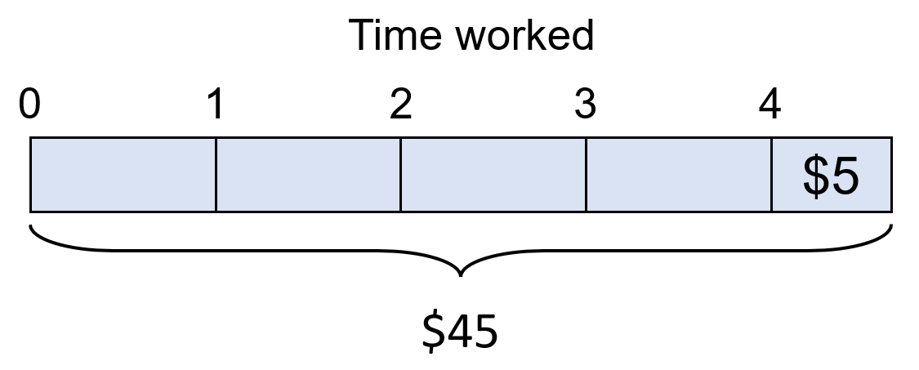
- Calculate the hourly pay if a person worked a 4-hour shift and earned $45 including a $5 tip.

$10/h
- Calculate hourly wage if a person earned $454.50 from 12 hours of work, including a $82.50 tip.

$31/h
- Determine the annual income if someone earns $15.25 per hour for 40 hours per week.

$31720
- Alyssa is paid $36.90 per hour and works a 8 hours day. Connor earns $320 per day. Who earns more per day and by how much?

$24.80
- Charlie works from 7:30 am to 3 pm Monday to Wednesday and from 8 am to 4 pm Thursday and Friday. His hourly rate is $27. Calculate his weekly wage.

$1039.50
- Russell and Gabrielle go to work in different department stores.
Russell is paid $1900 per fortnight. Gabrielle is paid $26.36 per hour.
How many hours per week must Gabrielle work to earn more money than Russell?

36.04 hours
- You receive two job offers:
$80 000 a year where you work 65 hours a week.
$36 an hour where you work 40 hours a week.
Which offer would you choose if you wanted the most money?

Job 1, as Job 2 is $74880/year

Penalty Rates
- Overtime is working beyond the agreed upon number of hours, which will depend on your job.
- Penalty rates are higher wages paid for:
  - Overtime
  - Weekend work
  - Night shifts
  - Public holidays

Penalty Rates
Time and a half (x1.5):
Multiply normal hourly wage by 1.5

Double time (x2):
Multiply normal hourly wage by 2

Double time and a half (x2.5):
Multiply normal hourly wage by 2.5.

Example Calculate overtime hours.
Convert $11.60/h to the overtime rate calculated at time-and-a-half.  Overtime rate $=\$11.60×1.5$  $=\$17.40$/h | Why did we multiply by 1.5?  …………… …… …… ……………… means to multiply the normal rate by 1.5  What does the $17.40/h represent?  How much you get paid per ………… if you work …………………
Convert $17.50/h to the overtime rate calculated at double time.  Overtime rate $=\$17.50×2$  $=\$35$/h | Why did we multiply by 2?  …………… …………… means multiply normal rate by 2.

Calculate the penalty rates.
- $\$14.90$/h at time-and-a-half.  $22.35/h | - $35.40/h at time-and-a-half.  $53.10/h
- $\$15.88$/h at double-time.  $31.76/h | - $42.56/h at double-time-and-a-half.  $106.40/h

Calculating Total Pay including Penalty Rates
$$Normal pay=Normal pay per hour×Number of normal hours \\ Overtime pay=Normal pay per hour×Number of overtime hours×Penalty rate \\ Total pay=Normal pay+Overtime pay$$

Example Calculate pay including penalty rates.
Lily normally works a 35-hour week at Coles and is paid $25 an hour.
Calculate her total pay for a week in which she works an additional 4 hours overtime.
$Normal pay=Normal pay per hour×Number of normal hours$
$=25×35$
$=875$
$Overtime Pay=Normal pay per hour×Number of overtime hours×penalty rate$
$=25×4×1.5$
$=150$
$Total Pay=Normal Pay+Overtime Pay$
$=875+150$
$=\$1025$
Ben normally works a 35-hour week as a kitchen hand and is paid $18.90 an hour.
Calculate his total wages for a week in which he works an additional 5 hours overtime at time-and-a-half.
Normal Pay $=$ …………… $×$ …………… $=$ ……………
Overtime Pay $=$ …………… $×$ …………… $×$ ………… $=$ ……………
Total Pay $=$ …………… $+$ …………… $=$ ……………
$803.25
Rina normally works a 35-hour week as an analyst and is paid $36.15 per hour.
Calculate her total wages for a week in which she works an additional 3 hours at time-and-a-half and 3 hours at double-time.
Normal Pay $=$ …………… $×$ …………… $=$ ……………
Overtime Pay $=$ …………… $×$ …………… $×$ ………… $=$ ……………
And: …………… $×$ …………… $×$ ………… $=$ ……………
Total Pay $=$ …………… $+$ …………… $+$ …………… $=$ ……………
$1644.83
Key ideas
- Penalty rates are a higher ……………… paid for working extra or unusual hours.
- Time-and-a-half is …… times the normal wage. …………… time is twice the normal wage.

Foundation
- Calculate the following overtime rates.
  - Time and a half when the hourly rate is $15.96/h
$23.94/h
  - Double time when the hourly rate is $23.90/h
$47.80/h
  - Double time and a half when the hourly rate is $17.40/h
$43.50/h
- Calculate the overtime pay given these overtime hours.
- Normal pay rate: $27.50/h
Overtime hours: 6
Overtime rate: time-and-a-half.
$Overtime Pay=Normal pay per hour×Number of overtime hours×penalty rate$
$=$ ……………………… $×$ …………………………… $×$ ………………
$=$ ………………………
$247.50
- Normal pay rate: $15.09/h
Overtime hours: 7
Overtime rate: double time.
$Overtime Pay=Normal pay per hour×Number of overtime hours×penalty rate$
$=$ ……………………… $×$ …………………………… $×$ ………………
$=$ ………………………
$211.26
- Complete the table for a company that pays overtime at time-and-a-half
 | Normal Hours | Hourly Rate | Normal  Pay | Overtime Hours | Overtime rate | Overtime Pay | Total Pay
 | 8 h | $24/h | $8 h×\$24$/h  $=\$192$ | 2 h | $24×1.5$  $=\$36/h$ | $$2×\$36$$  $$=\$72$$ | $\$192+\$72$  $$=\$264$$
 | 7 h | $28.20/h | $197.40 | 1 h | $42.30/h | $42.30 | $239.70
 | 6 h | $16.80/h | $100.80 | 3 h | $25.20/h | $75.60 | $176.40
 | 38 h | $25.75/h | $978.50 | 0.5 h | $38.63/h | $19.32 | $997.82
 | 38 h | $39.80/h | $1512.40 | 8 h | $59.70/h | $477.60 | $1990
- Karen earns $27.70 an hour. Calculate her weekly wage if she worked 33 hours at the normal rate and 6 hours at time-and-a-half.
Normal Pay $=$ …………… $×$ …………… $=$ ……………
$914.10
Overtime Pay $=$ …………… $×$ …………… $×$ ………… $=$ ……………
$249.30
Total Pay $=$ …………… $+$ …………… $=$ ……………
$1163.40

- Brian is a janitor and is paid $18.42 per hour. Calculate his weekly wage if he works 38 hours at the normal rate and 6 hours overtime at time-and-a-half.
Normal Pay $=$ ………………………………………………
$699.96
Overtime Pay $=$ ………………………………………………
$165.78
Total Pay $=$ ………………………………………………
$865.74

- Alexia works 16 hours at $20.20, 4 hours at time-and-a-half, and 3 hours at double-time.
Calculate her weekly wage.
Normal Pay $=$ ………………………………………………
$323.20
Overtime Pay $=$ ……………………………………………… (time-and-a-half pay)
$121.20
And: ……………………………………………… (double-time pay)
$121.20
Total Pay $=$ ………………………………………………
$565.60
- Calculate the following total weekly wages.
  - 38 hours at $22.10 per hour, plus 2 hours at time-and-a-half.

$906.10
  - 40 hours at $17.85 per hour, plus 3 hours at time-and-a-half.

$794.33
  - 37 hours at $18.32 per hour, plus 3 hours at time-and-a-half and 2 hours at double time.

$833.56

Development
- Vikash is a junior medical officer and is paid $28.24 per hour for a 35-hour week. He is paid overtime at double-time for the hours he works in excess of 35 hours. He worked 44 hours this week.
  - How many overtime hours did he work this week?
9 hours
  - Calculate his pay in a week in which he works 44 hours.
Normal Pay $=$
$988.40
Overtime Pay $=$
$508.32
Total Pay $=$
$1496.72
- Maggie is paid $42.70 per hour for a 38-hour week. She is paid overtime at time-and-a-half for any hours in excess of 38 hours. Calculate her total pay in a week in which she worked 55 hours.

$2711.45
- A job has a normal working hours pay rate of $9.20 per hour. Calculate the pay for 13 hours at normal pay and 6 hours at time and a half.

$202.40
- A job has a normal working hours pay rate of $11.50 per hour. Calculate the pay for 9 hours at normal pay, 3 hours at time and a half, and 2 hours at double time.

$201.25
- Julio is paid $956.08 for a regular 38-hour week
  - What is his hourly rate of pay?
$25.16/h
  - How many hours of overtime does he work if he works 41 hours that week?
3 hours
  - What is his wage for a week in which he works 41 hours, if overtime hours is paid at time-and-a-half?

$1069.30
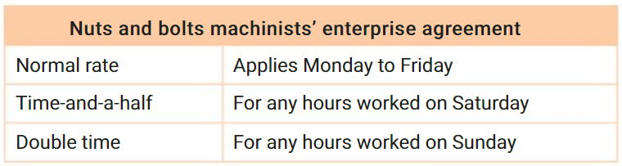
- Calculate the earnings for each of these employees working at Nuts and Bolts.

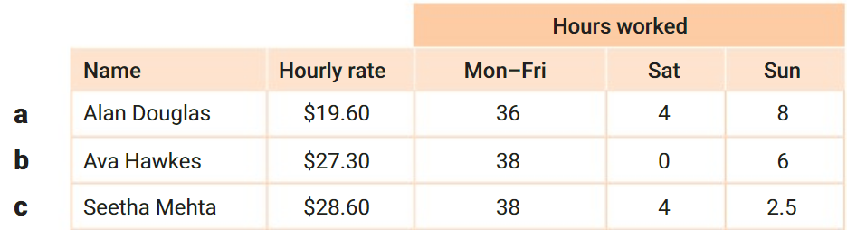

a) $1136.80
b) $1365
c) $1401.40
- Elegant Jewellery pays its staff at the following rates shown in the table. Calculate how much each employee earns per week:
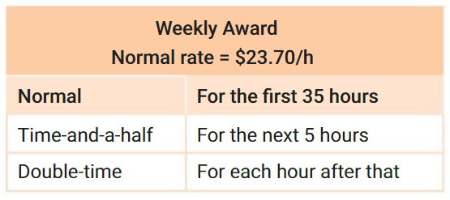
  - Grant, who works 33 hours.

$782.10
  - Kylie, who works 40 hours.

$1007.25

  - Noah, who works 44.5 hours.

$1220.55
- Stephen earns an hourly rate of $17.30 for the first 38 hours, time and a half for the next 3 hours and double time for each extra hour above that. Calculate his earnings if he works 44 hours in a week.

$839.05

Mastery
- Kaya works 3 hours at double-time rates. How many hours at normal rates is this?

6 hours
- Imogen works 3 hours at time-and-half rates. How many hours at normal rates is this?

4.5 hours
- Consider the following method of calculating total pay:
Worked Solution | Explanation
Josh earns $26.50/h and works a 38-hour week, with 6 hours at time-and-a-half and 3 hours at double time. Calculate total pay.  Equivalent normal hours:  $38+\left(6×1.5\right)+\left(3×2\right)=53$  Total pay $=26.50×53=\$1404.50$ |  | Describe what “Equivalent normal hours” is.  How much you would have to work to earn the same amount at the normal pay rate.  Check that the total pay is correct using the method:  Normal pay: …………………………  Time-and-a-half pay: …………………………  Double time pay: …………………………  Total pay: …………………………

- Calculate the equivalent normal hours for the following scenarios:
- Normal hours: 38 h  Time-and-a-half hours: 2 h  Double time hours: 0 h  $38+\left(2×1.5\right)+\left(0×2\right)=$ …………  41 | Normal hours: 38 h  Time-and-a-half hours: 3 h  Double time hours: 1 h  44.5
- Normal hours: 10 h  Time-and-a-half hours: 0 h  Double time hours: 3 h  16 | Normal hours: 12 h  Time-and-a-half hours: 2.5 h  Double time hours: 3.5 h  22.75

- Calculate the total pay using the equivalent hours method.
- Toby earns $23.80/h and in a week, he works 38 normal hours, 8 hours at time-and-a-half, and 3 hours at double time.  Equivalent normal hours:  Total pay:  $1332.80 | - Kwan earns $52.90 an hour and works 34 normal hours, 3 hours at time-and-a-half and 2.5 hours double time.  $2301.15
#
- Jim, a part-time gardener, earned $261 in a week. If he worked 12 hours during normal working hours and 4 hours overtime at time-and-a-half, what was his hourly rate of pay?

$14.50/h
- Sally earned $329.40 in a week. If she worked 10 hours during the week and 6 hours on Saturday at time and a half and 4 hours on Sunday at double time, what was her hourly rate of pay?

$12.20/h
- Jacky is paid $1042.32 for a regular 38-hour work week. How much does she earn in a week in which she works 44 hours, if any hours over 38 are paid at time-and-a-half?

$1289.18
- Billy worked for 35 hours at the normal hourly rate of pay and for five hours at double time. He earned $561.60 in total for this work. What was the normal hourly rate of pay?

$12.48/h

- Luke’s normal rate of pay is $15 per hour. Last week he was paid for 12 hours, at time-and-a-half. How many hours would Luke need to work this week, at double time, to earn the same amount?

9 hours
- Fill in the table.
Name | Hourly Rate | Normal hours | Time-and-a-half hours | Double time hours | Total Pay
Erich | $63 | 26 | 3.5 | 4.25 | $2504.25
Fiona | $43.50 | 6 | 6 | 6 | $1174.50
Gary | $40 | 2 | 8 | 8 | $1200
Herbert | $40 | 8 | 4 | 8 | $1200
Ian | $40 | 8 | 8 | 5 | $1200

- 2023 HSC Standard 1
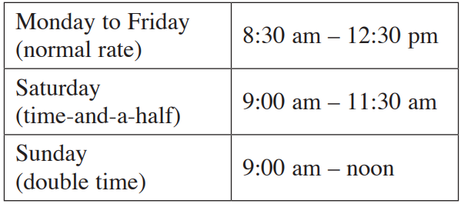
The hours worked last week by Rose are shown. Her normal rate of pay per hour is $24.05.
How much did Rose earn last week?

$330.69
- 2013 HSC Standard 2 Band 4
Luke's normal rate of pay is $24.80 per hour. In one week, he worked 14 hours at the normal rate, 4 hours at time-and-a-half, and 3.5 hours at double time.
He was also paid a wet weather allowance of $50 for the week.
What was his pay for the week?

$719.60

- 2016 HSC Standard 2 Band 4
Isabella works a 35-hour week and is paid at an hourly rate of $18.
Any overtime hours worked are paid at time-and-a-half.
In a particular week, she earned $1008.
How many hours in total did Isabella work in this week to earn this amount?

49 hours
- 2004 HSC Standard 2 Band 5
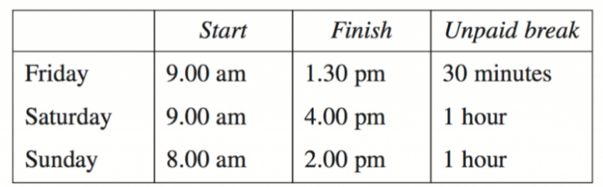
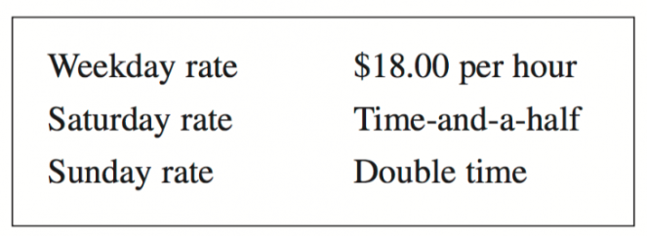
David is paid at these rates: His time sheet for last week is:

Calculate David’s gross (total) pay for last week.

$414
David decides not to work on Saturdays. He wants to keep his weekly gross pay the same.
How many extra hours at the weekday rate must he work?

9 hours

Piecework
- Piecework pays workers a set amount per completed task.
- Workers may earn more as they finish more tasks, encouraging faster work.

Pay from Piecework
$$Pay=Pay per task×Number of tasks \\ Number of tasks=\frac{Pay}{Pay per task}$$

Example Calculate pay from piecework.
Peta works at home sewing children’s tops. She is paid $3.20 for each top she produces. How much does she earn for 120 tops?  $Pay=Pay per task×Number of tasks$ $=\$3.20×120$ $=\$384$ | Larry earns $2.30 for every newspaper delivered. How many newspapers does he need to deliver to make $500?  $$Number of tasks=\frac{Pay}{Pay per task}$$ $=$ $\frac{\$500}{\$2.3}$ $=217.39$  He needs to deliver 218 newspapers  (we round up as 217 wouldn’t make $500)

- Johnathan sells 30 T-shirts at $14.50 each. How much did he earn?  $435 | - Dora is paid $7.50 per maths paper she marks. How much will she earn for marking 30 papers?  $225
- Sasha gets paid $2.37 for each parcel she delivers. How many does she need to deliver to make $250?  106 parcels | - A food delivery person is paid $5.50 for each delivery made. How many deliveries does he need to make to make $100?  19 deliveries

Key ideas
- Piecework is a fixed amount paid for …………… task completed.

Foundation
- Trinh has a job assembling jewellery boxes. He receives $1.27 for each box he assembles. Calculate how much he earns if he assembles 370 boxes:
Income = ………… × $1.27 = $ …………
$469.90
- Terry has a job assembling door locks. He receives 48 cents for each lock he assembles.
How much does he earn if he assembles 450 locks?

$216
- Jack makes leather belts. The piece rate is $1.25 each for the first 50 belts and $1.50 thereafter. What is his income for a day in which he produces 68 belts?

$89.50
- A production-line worker is paid $1.50 for each of the first 75 toasters assembled, then $1.80 per toaster thereafter. How much does she earn on a day in which she assembles 110 toasters?

$175.50
- Dimitri earns $7.20 for each box of fruit picked.
  - How many boxes must he pick to earn at least $200?
28 boxes
  - If he takes 4 hours to pick 12 boxes, what is his hourly rate of pay?

$21.60/h
- Patricia earns $1.03 for each dress she finishes in a clothing factory. If, on average, she can finish 20 dresses per hour and she works a 35-hour week, what are her average weekly earnings?

$721/week
- Joe works for a men’s hairdresser and is paid $15 for each haircut.
If he averages 26 haircuts per day for 6 days, how much does he earn?

$2340
- Mike delivers the local newspaper. He is paid $30 to deliver 500 newspapers.
How much is he paid for each one?

$0.06/paper

Development
- Some piecework is paid on a sliding scale, meaning the pay per item changes.
  - Alison makes flower arrangements. She is paid $6.80 for the first 20 arrangements.
If she supplies more than 20 she is paid at a higher rate of $8.90 per arrangement.
How much does she earn if she makes 28 flower arrangements?
($20×$ …………) $+$ (……… $×\$8.90$)$=$ ……………………………………………………………
$207.20
  - James frames photographs. He is paid $7.95 for the first 30 frames, then afterwards he is paid $9.50 per frame. How much does he earn if he frames 56 photographs?

$485.50
  - Malik picks fruit. He is paid $3.50 per bucket for the first 35 buckets. He is paid $4.25 for each extra bucket. How much does he earn if he picks 62 buckets of fruit?

$237.25
  - Troy sells internet packages. He is paid $65.70 for each sale he makes. If he makes more than 5 sales, each extra sale is paid an additional $23.95 per sale. How much does he earn if he makes 8 sales?

$597.45
- Jack is a roof tiler. He is offered a job of laying 205 m² for $3198. Jack wants a rate of $18/m². Should he take the job or not?

No, she shouldn’t. The rate offered is $15.60/m²
- Jillian is comparing landscape designers for her 175 m² garden.
Clara charges $180 + 7.70/m²
Joel charges $9/m²
Who offers the cheaper option for Jillian’s garden, and by how much?

Clara offers the cheaper option, by $47.50

Royalties and Commissions

Royalties
- A royalty is a payment to a copyright owner.
Musicians earn royalties from CD and online sales of their music.
Authors receive royalties based on book sales.
- Royalties are a percentage of sales.

Royalties
$$Royalty=Percentage×Sales$$

- Write the formula.
- Substitute given values.
- Solve to find the unknown.

Example Calculate pay from royalties.
Gerald is an author of a book. He is paid 2% of the sales of his book. If his book sales were $2 million, how much does he earn?  1. $Pay=Percentage×Sales$2. $=0.02×2 000 000$3. $=\$40 000$ | Taylor is a singer who is paid 30% of the total revenue from song sales. If she wants to earn $90,000, what value of sales is required?  1. $Pay=Percentage×Sales$2. $90 000=0.3×Sales$3. $\frac{90 000}{0.3}$ $=Sales$ $=\$300 000$

- Swift gets a royalty of 5% for her album sales. If the total value of albums sold is $100 000, how much does she get paid?  $5000 | - Phil’s book sales total $1 200 000. The publisher pays him a royalty of 0.4% of sales. How much does he earn?  $4800
- Cherie earns a royalty of 18% from her book sales. How much in sales is required for her to earn $500?  $2777.78 | - Charlotte wrote a play and earns a royalty of 0.8% from sales. If she wants to earn $3500 from a viewing of the play how much in sales is required?  $437 500

Commission
- Commission is how businesses often pay salespeople. It's a percentage of sales value.
- Some salespeople earn a base salary called a retainer, plus commission.
Commissions
$$Commission=Percentage×Sales \\ Total Pay=Retainer+Percentage×Sales$$

- Write the formula.
- Substitute given values.
- Solve to find the unknown.

Example Calculate pay from commission.
Worked Example | Your Turn
Georgia is paid a commission of 6% of the value of her sales. If Georgia sells $12 000 worth of goods, what is her commission?  1. $Pay=Percentage×Sales$2. $=0.06×12000$3. $=\$720$ | Emily earns a 14% commission on sales. In a particular week, she sold $12 530 worth of products. How much is her pay?  $1754.20
Charles sells washing machines. He is paid a retainer of $400 per week plus a commission of 3% of sales. How much does he earn in a week in which his sales are $5480?  1. $Pay=Retainer+Percentage×Sales$2. $=400+0.03×5480$3. $=\$564.40$ | Kyle is paid a base salary of $200 per week and a commission of 9% of sales. If Kyle sold $8000 worth of goods, how much is his pay?  $920
Last month, Aspen earned a total of $5220.  She was paid a retainer of $450 and earned a commission of 9% of sales.  How much in sales did she make?  1. $Pay=Retainer+Percentage×Sales$2. $5220=450+0.09x$3. $-450 -450$  $4770=0.09x$  $÷0.09 ÷0.09$  $\$53000=x$ | Harriet is a saleswoman. Last month she earned a total of $5922. She was paid a retainer of $2000 and a commission rate of 4% of sales. What is the value of her sales?  $98 050

Key ideas
- Commissions and royalties are both a ………………… of sales.
- Sometimes someone earning a commission will be paid a ……………, which is a small amount not affected by sales.

Sliding Scale Commission
- A sliding scale commission changes the percentage based on sales percentage.
- For example, a salesperson might earn:
  - 5% on the first $10 000 in sales.
  - 7% on sales between $10 000 and $20 000.
  - 10% on sales over $20 000.

Example Calculate pay from sliding scale commission.
Worked Example | Your Turn
Hilary is paid 5% commission for sales up to $10 000, then 7% commission for sales over $10 000. If she made $23 000 in sales last week, how much did she earn?  5% commission:  $0.05×10 000=\$500$  7% commission:  $$0.07×\left(23 000-10 000\right)=\$910$$  Total pay:  $500+910=\$1410$ | Emma earns 8% commission for sales up to $8000, then 12% commission for sales over this amount. If she made $19 000 in sales last week, how much did she earn?  $1960
Jeff is paid a 10% commission, but only on sales over $40 000. Furthermore, any sales in excess of $90 000 is paid at 15%. What is his income if he makes $120 000 in sales?  10% commission:  $0.1×(90 000-40 000)=\$5000$  15% commission:  $$0.15×\left(120 000-90 000\right)=\$4500$$  Total pay:  $5000+4500=\$9500$ | Kerri is paid:  2% commission on sales up to $35 000,  5% on sales between $35 000 and $80 000,  8% on sales in excess of $80 000  What is her income if she makes $95 000 in sales?  $4150

Foundation
- Find the commission on these sales.
- Sales: $15 540.  Commission rate: 12%  $Pay=Percentage×Sales$  $=$ …………… $×$ ………  $1864.80 | - Sales: $17 880.  Commission rate: 9%  $1609.20
- Reggi works as a salesperson and is paid a commission of 4% of the value of her sales. Calculate Reggi’s commission for a week in which she sells $6800 worth of goods.  $272 | - Phillipa works as a salesperson and is paid a commission of 5% of the value of her sales. If Phillipa sells $16 000 worth of goods one week, what is her commission?  $800
- An actress is paid a 2.5% royalty on ticket sales to her latest movie. How much does she earn if the box office was $2,403,556?  $60 088.90 | - Mike works as a salesperson and is paid a commission of 1.55% of the value of her sales. If he sells $22 000 worth of goods one week, what is his commission?  $341
- Ibraham sells washing machines. He is paid a fixed wage of $270 per week plus a commission of 4% of sales. Calculate how much he earns in a week in which his sales are $6240.
Commission = 4% × $………… = $…………
Weekly earnings = retainer + commission
= $……… + $……… = $ …………
$519.60
- Amy works at Best Bookshop. During one week she sells books valued at $800.
If she earns $450 per week plus 5% commission, how much does she earn in this week?

$490
- Jason works for a caravan company. If he sells $84000 worth of caravans in a month, and he earns $650 per month plus 4% commission on sales, how much does he earn that month?

$4010

Development
- Complete the table.
Employee | Weekly Retainer | Commission Rate | Sales | Commission | Total Weekly Pay
Olivia | $0 | 5% | $10 000 | $500 | $500
Stella | $1000 | 5% | $10 000 | $500 | $1500
Emma | $1000 | 10% | $10 000 | $1000 | $2000
Georgia | $560 | 1% | $40 000 | $400 | $960
Keira | $290 | 0.5% | $110 000 | $550 | $840
Katelyn | $1500 | 1.25% | $45 500 | $568.75 | $2068.75

- Steve sells clothing. He earns a commission of 18.5% of all weekly sales in excess of $2000. Calculate how much commission he earns on sales of $5800.
Excess = $………… − $2000 = $…………
$3800
Commission = ………% × $………… = $…………
$703
- Fiona sells cleaning equipment. She earns a commission of 17.5% of all weekly sales in excess of $10 000. How much commission does she earn on weekly sales of $24000?

$2450
- Jane sells jewellery. Her commission is based on a sliding scale of 6% on the first $2000 of her sales, 3.5% on the next $1000, and 2% thereafter.
What is Jane’s commission when her total sales are $5670?

$208.40
- 2008 HSC Standard 2 Band 4
Bob is employed as a salesman. He is offered two methods of calculating his income.
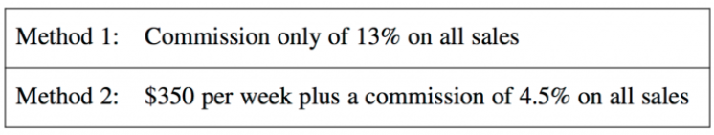

Bob’s research determines that the average sales total per employee per month is $15 670.
If Bob were to choose a method of payment based on the average sales figures, state which method he should choose to earn the greater income. Justify your answer with calculations.
Method 1: $0.13×15670=\$2037.10$
Method 2: $\frac{\left(350×52\right)}{12}$ $+0.045×15670=\$2221.82$
Method 2 is better

Mastery
- A real estate agent is paid according to the following commission schedule:
Base commission of $3000
2% on first $500 000 of sale price.
2.5% on next $500 000 of sale price
3% on remaining sale value.
How much does a real estate agent earn selling a house worth:
- $500 000  $13 000 | - $950 000  $24 250 | - $2 550 000  $72 000

- 2022 HSC Standard 2 Band 3
A real estate agent's commission for selling houses is 2% for the first $800 000 of the sale price and 1.5% for any amount over $800 000.
Calculate the commission earned in selling a house for $1 500 000.

$26 500
- A new children’s book author is offered a choice of $100000 cash or a 4% royalty on sales. What would the sales need to be to match the cash offer?

$2 500 000
- Harry is a salesperson. He earns a basic wage of $300 per week and receives commission on all sales. Last week he sold $20 000 worth of goods and earned $700.
What was Harry’s rate of commission?

2%
- A door-to-door salesman sells 10 security systems in one week at $1200 each. For the week, he earns a total of $850, including a retainer of $300 and a commission.
Find his percentage commission correct to 2 decimal places.

4.58%
- William has two choices for payment:
1. $600 per week + 2% commission
2. 3.5% commission
How much does he need to sell per week so that he earns the same amount from both options?

$40 000

Salary
- A salary is yearly pay, often written as per annum (p.a.).
- Employers divide up salary and pay it weekly, fortnightly, or monthly.
- When Mr Ding began teaching, he was paid $72 000 p.a.
Every fortnight, he was paid $\frac{1}{26}$ of $72 000.
- Salaried workers get a fixed yearly pay and often enjoy paid leave.
- Some may also earn overtime, but this is rare.

Calculations involving Salary
$$Total Pay=Pay per period×Number of periods \\ Pay per period=\frac{Total pay}{Number of periods} \\ Number of periods=\frac{Total pay}{Pay per period}$$

Example Convert pay rates.
When Mr Ding first started teaching, he earned $72 000 annual salary.  He gets paid per fortnight.  How much does he get paid per fortnight?  $$Pay per period=\frac{Total pay}{Number of periods} \\ =\frac{\$72 000}{26 fortnights} \\ =\$2769.23/fortnight$$ | Harry works full-time and earns a salary of $1600 per week.  How much does he earn in a year?  $$Pay=Pay per period×Number of periods \\ =\$1600/week×52 weeks \\ =\$83200$$

- Rebecca gets paid $120 000 p.a., how much is this per fortnight?  $4615.38 | - Ariel is paid $7250 per month.  What is her annual salary?  $87 000

Key ideas
- Salary is different to wages as it is not paid ……………………, but a fixed amount per ……………

Foundation
- Adam earns $48 000 a year. How much does he earn in:
- 1 month  $$Pay per period=\frac{Total pay}{Number of periods}$$  $4000 | - 1 week  $923.08

- Michiko works part-time and earns $283 per week. How much does she earn in:
- 1 fortnight  $$Total pay=Number of periods×Pay per period$$  $566 | - 1 year  $14716

- Explain why you cannot divide by 4 to find weekly income from monthly income.

1 month is not 4 weeks.
- Jenny works as a pastry chef. Her salary is $51 064 per annum.
Express this salary as an amount:
- Per month  $$Pay per period=\frac{Total pay}{Number of periods}$$  $4255.33 | - Per week  $982

- Amy earns $19 884.80 per annum for part-time work. Find how much she earns:
- Per month  $$Pay per period=\frac{Total pay}{Number of periods}$$  $1657.07 | - Per fortnight  $764.80

- Shirley earns $765 per week. How much does she earn in:
- 5 weeks  $3825 | - 1 year  $39780
- 1 month  $3315 | - For part c, a student multiplied weekly pay by 4. Explain why this is incorrect.  4 weeks is not a month.

- Georgina works for 3 days a week and earns of $670.85 per week.
How much does she earn per:
- Fortnight  $1341.70 | - Year  $34884.20 | - Month  $2907.02

- Jim works for 4 days a week and earns of $842.66 per week.
Find how much he earns for these periods to the nearest cent.
- Fortnightly  $1685.32 | - Yearly  $43 818.32 | - Monthly  $3651.53

- Harry works full-time and earns a salary of $68 600 p.a. How much does he earn per:
- Week  $1319.23 | - Fortnight  $2638.46 | - Month  $5716.67

- Helene works full-time and earns a salary of $74 250 p.a.
Complete the following to find how much she earns for these periods to the nearest cent.
- Week  $1427.88 | - Fortnight  $2855.77 | - Month  $6187.50

- Jeffrey earns $5205.50 per month. Calculate how much he earns per:
- Year  $62 466 | - Week  $1201.27 | - Fortnight  $2402.54
- Answer these questions. Round all answers to 2 decimal places.
- Convert $68 484 p.a. salary to weekly pay.  $1317 | - Ken earns $182 940 p.a. salary. Convert this to fortnightly pay.  $7036.15
- What is Yasmeen’s annual salary if her salary per fortnight is $1610?  $41 860 | - Dylan receives a weekly salary payment of $1560. What is his annual salary?  $81 120
- Determine the wage for a 37-hour week for someone earning $12 per hour.  $444 | - Grace earns $525 in a week. If her hourly rate of pay is $12.50, how many hours does she work in the week?  42 hours
- What is Zachary’s fortnightly income if he earns a salary of $43 056?  $1656 | - Kim is a plumber who earned $477 for a day’s work. He is paid $53 per hour. How many hours did Kim work on this day?  9 hours
- Brianna earns $16.65/h and works 15 hours per week. How much does she earn in 1 year?  $12 987 | - Ehab earns $97 286.40 per year.  How much is this per month?  $8107.20
- Johnson earns $5126 monthly.  How much is this per year?  $61 512 | - Dave earns $2895 per fortnight.  How much is his yearly salary?  $75 270

Development
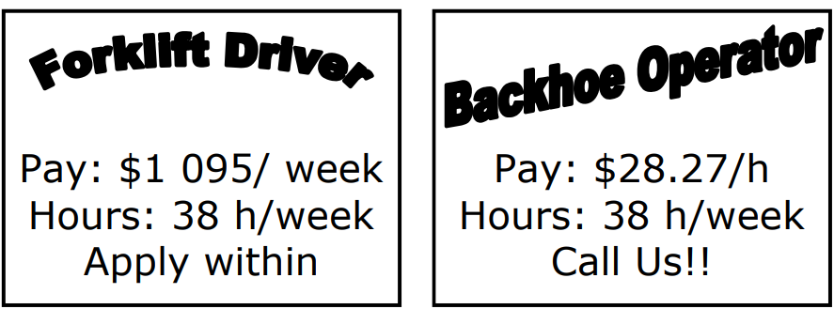
- Look at the two ads.

  - Convert the forklift job to an annual wage.
$56 940
  - Convert the backhoe job an annual wage.
$55 861.62
  - Which job pays better in a year?
Forklift job

- Look at the two ads and determine which job pays better over a year.

  - Convert the HR job to an annual wage.
$72 280
  - Convert the Recruitment job an annual wage.
$71 884.80
  - Which job pays better in a year?
HR specialist
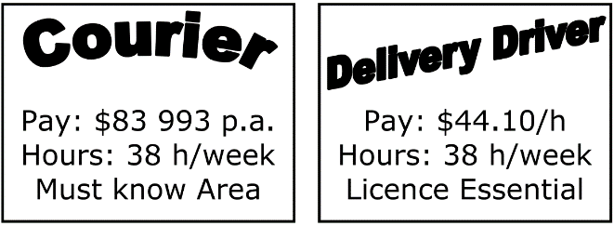
- Look at the two ads and determine which job pays better over a year, and by how much.

Courier: $83993, Delivery: $87141.60. Delivery driver by $3148.60

- Look at the two ads and determine which job pays better over a year, and by how much.

Assistant: $28 535, Customer: $30 602. Customer service by $2067
- Convert these wages rates to an annual income. Round to 2 d.p.
- $25.25/h, 38 hours per week.  $49 894 | - $21.65/h, 14 hours per week.  $15 761.20
- $35.75/h, 25 hours per week.  $46 475 | - $22.42/h, 30 hours per week.  $34975.20

- Convert the annual income to an equivalent hourly rate. Round to 2 d.p.
- $30 526 p.a., 38-hour week.  $15.45/h | - $48 253 p.a., 30-hour week.  $30.93/h
- $62 251.22 p.a., 28-hour week.  $42.75/h | - $25 994.60 p.a., 16-hour week.  $31.24/h

- Convert the monthly income to a weekly rate. Round to 2 d.p.
Note: do NOT divide by 4. Convert to annual income first, then divide.
- $1927.61 monthly.  $444.83/wk | - $8825.35 monthly.  $2036.62/wk
- $4416.23 monthly.  $1019.13/wk | - $3421.40 monthly.  $789.55/wk

- Convert the weekly income to a monthly rate. Round to 2 d.p.
Note: do NOT multiply by 4. Convert to annual income first, then divide.
- $420 weekly.\  $1820/mth | - $620 weekly.  $2686.67/mth
- $1123.20 weekly  $4867.20/mth | - $849.50 weekly.  $3681.17/mth

Mastery
- Calculate the monthly rate of pay.
- $24/h for a 16-hour week.  $1664/mth | - $48/h for a 38-hour week.  $7904/mth
- Calculate the hourly rate of pay.
- $3250/month at 25 hours/week.  $30/h | - $2372.50/month at 30 hours/week  $18.25/h
- Stella earns $68 840 per year.
Emma earns $1350 per week.
Georgia earns $5700 per month. Who earns the most?

Emma earns the most.
- Keira earns $2665/week
Katelyn earns $11 650/month.
Isabella earns $57/h for a 37-hour week.
Saskia earns $5888/fortnight. Who earns the most?

Saskia earns the most.
- Harriet earns $32.85/h for a 28-hour week.
Edith earns $1838/fortnight.
Romaine earns $935/week.
Trinity earns $4050/month. Who earns the most?

Romaine earns the most.

Bonuses and Allowances
- Bonuses are one-off rewards for good work, usually paid at the end of the year.
- Allowances are extra pay as an incentive to work in difficult or dangerous working conditions, leadership positions, or as compensation for work-related expenses, e.g. uniforms and travel.

Example Calculate pay from bonuses and allowances.
Renee worked hard throughout the year and was rewarded a bonus of 6% of her yearly income. If her normal yearly income is  $58 000, calculate how much she was paid in total.  Bonus $58 000×0.03=\$3480$  Total pay $58 000+3480=\$61 480$ | Vicki earns $25.45 per hour as a chef. If she is rostered on the ovens, she receives a heat allowance of $24 per day. Find her weekly pay if she works 4 hours each weekday and is rostered on the ovens for 2 of the days.  Normal pay $25.45×4×5=\$509$  Allowance $24×2=\$48$  Total pay $509+48=\$557$

- Jeremy receives a bonus of 3% of his annual salary of $43 600. Find his total pay.  $44908 | - Karla receives a bonus of 1 month’s salary. If her annual pay is $96 000, calculate her total pay.  $104 000
- Jovan earns $34.20 per hour for an eight-hour day. He is paid a supervisor allowance of $30 per day. Find his pay for a week in which he works 5 days and is supervisor for 3 of the days.  $1458 | - Rose is paid $20.70 per hour welding bins. If the temperature is over 30°C, she is paid an extra $13 per day. Find her pay for a 35-hour week in which there are two days over 30°C.  $750.50

Foundation
- Paul works for a builder and earns a salary of $66 000 per year. At the end of the year, the builder decides to pay Paul a bonus equal to one month’s salary. Calculate Paul’s bonus.

$5500
- Seveta works as a clerk and earns a salary of $74 760 per year.
At the end of the year her employer pays her a bonus of one month’s salary.
  - Calculate Jenni’s bonus.

$6230
  - Calculate her total annual earnings.

$80 990
- Jenni works as a secretary and earns a salary of $58 600 per year.
At the end of the year her employer pays her a bonus of three month’s salary.
  - Calculate Jenni’s bonus.

$14 650
  - Calculate her total annual earnings.

$73 250
- Jeremy receives a bonus of 3% of his annual salary of $43 600.
Calculate his total pay for the year.
Bonus = ………% of $43 600 = ……………
Total annual pay = …………… + …………… = …………………
$44 908
- Amy is paid $23.50 per hour and works a normal 35-hour week. At the end of the year her employer pays her a bonus of 5% of her yearly wages. Calculate Amy’s total annual pay.

$44 908.50
- Harry works in a timber yard and is paid $21.40 per hour. He receives a dust allowance of $12.50 per day. Find his pay for a 5-day, 40-hour week.
Normal Pay: …………$×$…………$×$…………$=$…………
Allowance: …………$×$…………$=$…………
Total Pay: …………$+$…………$=$…………

$918.50

Development
- A window washer is paid $22.50 per hour and a height allowance of $55 per day. In one week, he works 9 hours each weekday.
  - Calculate the amount earned each weekday.

$257.50
  - Calculate his total weekly earnings for five days of work.

$1287.50
- Kathy is a scientist who is working in a remote part of Australia. She earns a salary of $86840 plus a weekly allowance of $124.80 for working under extreme and isolated conditions. Calculate Kathy’s fortnightly pay.

$3589.60
- Zofia earns $590 per week. What is her total weekly wage in which she received a 12% bonus?

$660.80
- For completing a project ahead of schedule, each member of the project team was given a bonus of 3% of the after-tax profit made.
Calculate the bonus paid to each team member if the after-tax profit was $120 000.

$3600
- A company made a profit of $194 000 for the year. The owner decided to share 60% of the profit between her 80 employees as a bonus. Calculate the bonus paid to each employee.

$1455
- Shirley earns $67 000 per year. At the end of the year her company had revenue of $2.92 million and costs of $2.71 million. Shirley is paid a bonus of 1% of the profits of the company. How much is her income for that year?

$69 100
- 2013 HSC Standard 2 Band 5
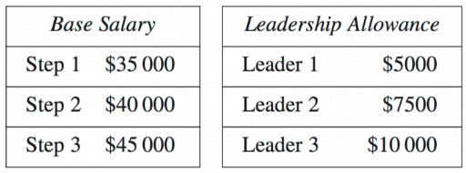
An enterprise agreement has the following annual salary arrangements:
George's employer pays 6% more base salary than the enterprise agreement. He is on Step 3 and receives an allowance for Leader 2.
What is George's gross monthly pay?

$4600

Leave Loading
- Leave loading is an increase in an employee’s pay during their 4 weeks of annual leave.
- It is usually an extra 17.5% of 4 weeks’ pay.
- Leave loading is also called holiday loading.
- Leave loading is intended to support workers on holiday who do not have the opportunity to earn extra income from penalty rates, bonuses, commissions, etc.

Leave Loading
$$Leave loading=0.175×Weekly pay×4 \\ Total holiday pay=Weekly pay×4+Leave loading$$

Example Calculate leave loading and holiday pay.
Calculate Ray’s annual leave loading if he earns $1550 per week.  $$Leave Loading=0.175×Weekly Pay×4 \\ =0.175×1550×4 \\ =\$1085$$ | Calculate holiday pay for an employee who earns a salary of $70 000 p.a.  $$Weekly Pay=70000÷52=\$1346.15 \\ Leave Loading=0.175×Weekly Pay×4 \\ =0.175×1346.15×4 \\ =942.31 \\ Holiday Pay=Weekly Pay×4+Leave Loading \\ =4×1346.16+942.31$$

- If an employee’s weekly rate of pay is $800 and they take 4 weeks of annual leave, what is their leave loading?  What is their holiday pay?  $3760 | - Bob earns a salary of $90 000 p.a. Calculate their leave loading.  What is their holiday pay?  $8134.62

Key ideas
- Most full-time employees get …… weeks of annual leave.
- Leave loading is an extra …………% of 4 weeks’ pay.
- Holiday pay includes leave loading, so therefore is …………% of 4 weeks’ pay.

Foundation
- Convert these to 4 weeks’ pay. Round to the nearest cent.
- $1365.20/week  $=$ $………… /4 weeks  $5460.80 | - $623.17/week  $2492.68 | - $1684.83/week  $6739.32
- $2560.77/fortnight  $=$ $………… /4 weeks  $5121.54 | - $1363.45/fortnight  $2726.90 | - $435.65/fortnight  $871.30
- $63 854.45/year  $=$ $………… /week  $=$ $………… /4 weeks  $4914.96 | - $38 655.22/year  $2973.48 | - $94501.50/year  $7269.36
- $4670/month  $=$ $………… /year  $=$ $………… /week  $=$ $………… /4 weeks  $4310.76 | - $3622/month  $3343.40 | - $4682/month  $4321.84
- $24.85/hr, 7 hours/day,  5 days/week  $=$ $………… /day  $=$ $………… /week  $=$ $………… /4 week  $3479 | - $33.55/hr, 8 hours/day,  5 days/week  $5368 | - $41.80/hr, 7.5 hours/day,  4 days/week  $5016

- Find leave loading by calculating 17.5% of these amounts.
- 17.5% of $560  $98 | - 17.5% of $1778  $311.15 | - 17.5% of $1603.52  $280.62

- Joseph earns $850 per week.
  - Calculate 4 weeks pay.
$3400

  - Calculate the leave loading.
$595

- Lucas earns $725.50 per week working as a travel agent. Calculate his total holiday pay.
4 weeks pay = $725.50 $×$ ……… $=$ …………
Leave loading = 17.5% $×$ ………… $=$ …………
Total holiday pay = ………… $+$ ……… $=$ …………
$3409.85
- Caleb earns $673 per week and is paid a holiday loading of 17.5% on 4 weeks pay.
Calculate his holiday pay.
4 weeks pay = ………… $×$ ………… $=$ …………
Holiday loading = ………% $×$ ………… $=$ …………
Total Holiday pay = ………… $+$ ………… $=$ …………
$3163.10
- Riley earns $425 per week as a horse trainer.
  - How much will his holiday loading be if he takes 4 weeks holiday?

$297.50
  - What will be the amount of his holiday pay?

$1997.50
- Kylie earns $760 per week.
She is entitled to 4 weeks annual leave and receives holiday loading of 17.5%.
Calculate Kylie’s holiday pay.

$3572
- Mary earns $800 per week.
Calculate her holiday pay for 4 weeks, including leave loading at 17.5%.

$3760
- Yiwen earns $3204 per fortnight.
She is entitled to 4 weeks annual leave and receives an additional holiday loading of 17.5%. Calculate her holiday pay.

$7529.40

Development
- William earns $97 080 per year.
  - Calculate 4 weeks pay.
$7467.69
  - Calculate the leave loading.
$1306.85
  - Calculate total holiday pay.
$8774.54

- Elena earns $24.50 per hour for a 36-hour week.
She takes 4 weeks holidays to travel overseas.
  - What will be her wage for 4 weeks?
$3528
  - How much will her holiday loading be?
$617.40
  - What amount of money will Elena be paid altogether for her holiday?
$4145.40

- Laura works a 37-hour week at a rate of $20.50 per hour.
When she takes her 4 weeks annual leave, she is paid a loading of 17.5%.
What is Laura’s holiday pay when she takes her leave?

$3564.95
- The formulas for leave loading calculations can be simplified to:

$$Leave Loading=4x×0.175 \\ Total Holiday Pay=4x×1.175$$
Where $x$ is weekly pay. Use these formulas to quickly answer the following:
  - Wesley earns $43 940 per year.
He is entitled to 4 weeks annual leave and receives an additional holiday loading of 17.5%. Calculate Wesley’s leave loading.

$591.50
  - James earns $114 802 per year.
He is entitled to 4 weeks annual leave and receives an additional holiday loading of 17.5%. Calculate his total holiday pay.

$10376.33
  - Tony earns $3 389 per month.
He is entitled to 4 weeks annual leave and receives an additional holiday loading of 17.5%. Calculate his total holiday pay.

$3675.76

Mastery
- Hannah receives 17$\frac{1}{2}$% holiday loading of $665 for her 4 weeks of annual leave.
What is her normal weekly pay?

- Find normal weekly pay if total holiday pay, including 4 weeks leave loading at 17.5%, is $6657.

- Find 4 weeks of normal pay if leave loading at 17.5% of 4 weeks’ pay was $784.70

- Mel is taking her holidays. She receives $2937.50.
This includes her normal pay and 17.5% leave loading.
How much is the leave loading?

$437.50
- Charlie is taking his holidays and receives 4 weeks’ holiday pay, including leave loading, of $4592.60.
Calculate his annual salary.

$50811.80
- Jim receives holiday loading of 17.5% of 4 weeks’ pay.
His loading was $996.80.
Find his normal hourly pay if he works 40 hours a week.

$35.60/h
- Chloe’s annual salary is $72 800.
Chloe’s employer is increasing her annual salary by 1% but removing the 17.5% leave loading on 4 weeks’ pay.
Is she better or worse off, and by how much?

She is worse off by $252

Taxable Income
- Tax is money you pay to the government so they can spend it on government services.
- Income tax is money the government collects from individuals.
- It a percentage of your annual taxable income.
- The Australian Taxation Office (ATO) collects taxes.

Gross Income
The total income you earn before tax.
This includes all income: from full-time work, interest or dividends from investments, renting out owned property, etc.

Taxable Income
$$Gross income - Allowable tax deductions$$

Taxable income is rounded down to the nearest whole dollar.

Allowable Tax Deductions
- Work related expenses:
  - The expenses must relate directly to earning your income.
  - You must have spent the money yourself and weren’t reimbursed.
  - You must have a receipt or invoice to prove it.
- Donations made to charity.
- Union fees.
- Tax agent fees.
- Allowable tax deductions will be different depending on your job.

Example Calculate taxable income
Annie earned $45320 in wages, $665 interest from her savings, and a bonus of $800. She had union fees of $600 and donated $75 to charity. What is her taxable income?  $45320+665+800-600-75$  $=\$46110$ | Olivia earned a salary of $132 000 and $890 in interest from her investments. She had work-related expenses of $1750 and a tax agent fee of $100. What is her taxable income?  $131 040

Key ideas
- Taxable income is …………………… $-$ ………………………
- Gross income includes all income from all sources, including from work, ……………… from investments, …………… out owned property.
- Allowable tax deductions include ……………-related expenses, union fees, and ………………… to charity.

Foundation
- Benjamin has a gross income of $84 000. What is Benjamin’s taxable income if he has allowable tax deductions of $12 520?

$71 480
- Chris earns a gross salary of $67 840 per year. His tax deductions total $3462.
Calculate Chris’s taxable income.

$64 378
- Eliza earned $88 784 from her employer in the last financial year. She also earned bank interest of $380. Eliza spent $240 on books, $520 on stationery and $380 on a printer, all of which are needed for her work.
  - What is Eliza’s gross income?
$89 164
  - What are Eliza’s total allowable tax deductions?
$1140
  - Calculate Eliza’s taxable income.
$88 024
- Consider the following table:
Income (p.a.) | Deductions (p.a.)
Salary $94 750  Bank Interest $359.15  Share Dividends $82.45 | Union Fees $625.90  Uniform $282  Charity Donation $85

  - Calculate total gross income
$95 191.60
  - Calculate total deductions
$992.90
  - Calculate taxable income
$94 198.70
- Consider the following table:
Income (p.a.) | Deductions (p.a.)
Salary $57 521  Bank Interest $108.42  Rent $30 928 | Union Fees $857  Work laptop $1550

  - Calculate total gross income
$88 557.42
  - Calculate total deductions
$2407
  - Calculate taxable income
$86 150.42

Development
- Olivia is a police officer who earned an annual gross income of $63 620. She claimed a tax deduction for a utility belt ($160), a pair of safety glasses ($390), bulletproof vest ($1240) and handcuffs ($420). Calculate Olivia’s annual taxable income.

$61 410
- Mackenzie earns a gross weekly pay of $1120. She donated $405 to charity this year.
What is Mackenzie’s annual taxable income?

$57 835
- Daisy earns a gross fortnightly pay of $2802. She earned $4055 this year in interest from her savings. She pays union fees of $900 per year and has other allowable deductions totalling $528. What is her annual taxable income?

$75 479
- An Australian banker bought plane tickets worth $1500 to go to a conference related to banking. The company reimbursed him for this purchase. Explain why this is not an allowable tax deduction.

For an expense to be tax-deductible, the taxpayer must have personally incurred the expense without reimbursement.
- Alannah earns $58.21/h and works a 38-hour week. She has work-related clothing expenses of $6.30/week and union fees of $11.20/week. She earned $33.70 in bank interest for the year. Calculate her annual taxable income.

$114 146.66
- Loretta earns $2829 per fortnight. She has work-related clothing expenses of $8.90 per week and union fees of $15.10/week. She earned $78 in dividends for the year and donated $80 to charity. Calculate her annual taxable income.

$72 304

Income Tax Table

Tax Table
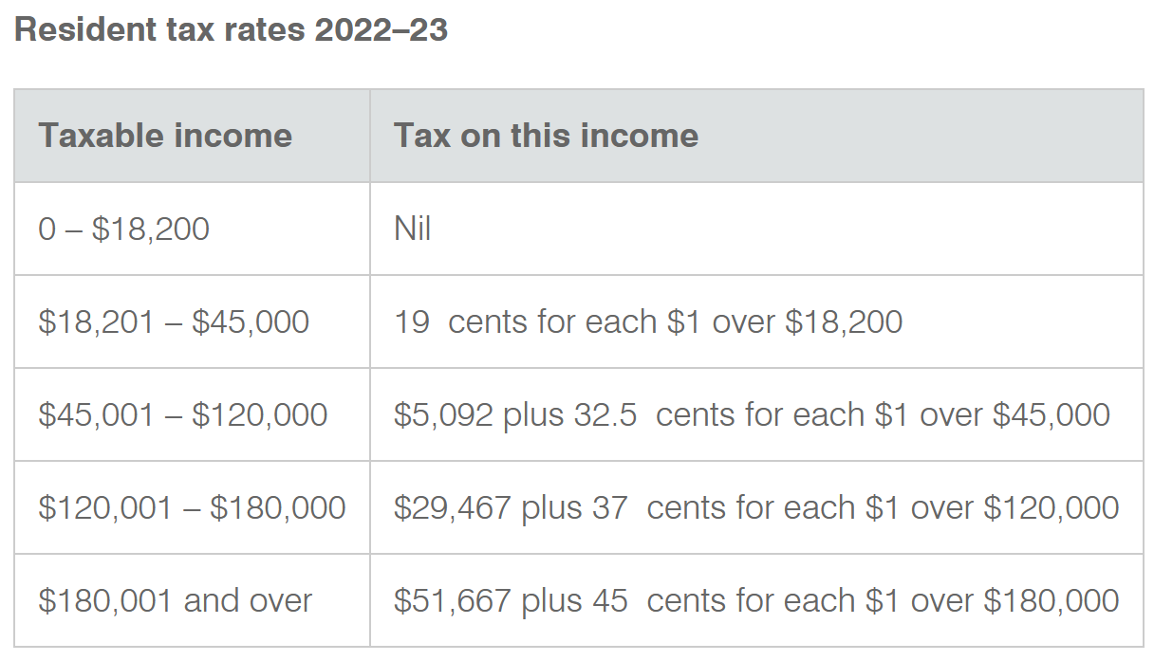

Income Tax Table
- The tax table helps you calculate the annual tax payable (tax you need to pay).
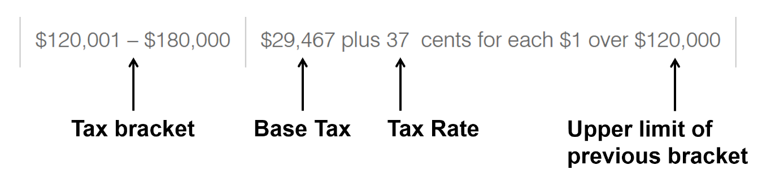

- Determine the tax bracket (row of the table).
- Calculate the excess. $Excess=Taxable income -Upper limit of previous bracket$.
- Use the formula: $Tax Payable=Base tax+Tax rate×Excess$.

Net (after-tax) Income
- Net income refers to gross income minus taxes and other deductions, such as superannuation. We will focus on tax for now.

Net Income
$$Net income=Gross income-Tax payable$$

Example Calculate tax payable using an income tax table.
Calculate the tax payable on a taxable income of:
Worked Example | Your Turn
- $12 000  This is the first tax bracket.  The tax payable is $0. | $8000  This is the …………… tax bracket.  The tax payable is ………  $0
- $25 000  This is the second tax bracket.  $$Excess=(Taxable income) -\left(Upper limit prev bracket\right)$$  $=25 000-18 200$  $=\$6800$  $$Tax Payable=\left(Base tax\right)+\left(Tax rate\right)×\left(Excess\right)$$  $=0+0.19×6800$  $=\$1292$ | $40 000  This is the …………… tax bracket.  $$Excess=(Taxable income) -(upper limit prev bracket)$$  $$Tax Payable=\left(Base tax\right)+\left(Tax rate\right)×\left(Excess\right)$$  $4142
- $63 000  This is the third tax bracket.  $Excess=(Taxable income) -(Upper limit prev bracket)$.  $=63 000-45 000$  $=\$1800$  $$Tax Payable=\left(Base tax\right)+\left(Tax rate\right)×\left(Excess\right)$$  $=5092+0.325×18000$  $=\$10942$ | $165 000  This is the …………… tax bracket.  $$Excess=(Taxable income) -(Upper limit prev bracket)$$  $$Tax Payable=\left(Base tax\right)+\left(Tax rate\right)×\left(Excess\right)$$  $46117
What is a tax bracket?
……………………………………………………………………………………………………………
What is the excess?
……………………………………………………………………………………………………………
Describe what the tax rate is.
……………………………………………………………………………………………………………

Investigation A tax misconception.
Your friend currently earns $119,000 a year. She is about to get a $3000 pay rise.
In which tax bracket is she in currently? ……………………………………………………
In which tax bracket will she be in afterwards? ……………………………………………………
Your friend says: “I don’t want the pay rise. The government will start taxing me at 37%, rather than 32.5%, which means I’ll have less money than before!”
Explain to your friend why she is incorrect, using mathematical reasoning:
Tax before pay rise ($119 000)
This is the …………… tax bracket.
$Excess=(Taxable income)-(upper limit prev bracket)$.
$=$ ………………….. $-$ ……………………………
$=$ …………………..

$Tax Payable=\left(Base tax\right)+\left(Tax rate\right)×\left(Excess\right)$.
$=$ ………….. $+$ ……….. $×$ ……………
$=$ ……………

$After tax income=Gross income-Tax payable$
$=$ …………….. $-$ ………………
$=$ ………………

Tax after pay rise ($………………)
Tax bracket:
Excess $=$ …………………………………………………………………………………………
…………………………………………………………………………………………
…………………………………………………………………………………………

Tax payable $=$ ……………………………………………………………………………………
……………………………………………………………………………………
……………………………………………………………………………………

After tax income $=$ ……………………………………………………………………………
……………………………………………………………………………
……………………………………………………………………………

The new tax rate is only on each …………………… dollar you earn.

Foundation
- Refer to the tax table to decide which tax bracket these annual incomes fall into.
(First, Second, Third, Fourth, or Fifth)
  - $86 000 p.a. …………………
third
  - $43 821 p.a. …………………
second
  - $12 565 p.a. …………………
first
  - $125 213 p.a. …………………
fourth
  - $110 422 p.a. …………………
third

- Use the tax table to calculate the tax payable on a taxable income of:
  - 15,000
    - Look at the ………… row of the tax table.
    - The tax on this income is: …………………
$0
  - $34,000
    - Look at the ………… row of the tax table.
    - The tax on this income is ……… cents for every dollar over ………………
Excess: $34,000 $-$ …………… $=$ ……………
Tax: ………… $×$ …………… $=$ ………………
$3002
  - $72,283
    - Look at the ………… row of the tax table.
    - The tax on this income is …………… plus ……… cents for every dollar over …………
Excess: …………… $-$ …………… $=$ …………
Tax: ……………… + ………… $×$ ………… $=$ ………………
$13 958.98
  - $153,912
    - Look at the ………… row of the tax table.
    - The tax on this income is …………… plus ……… cents for every dollar over …………
Excess: …………… $-$ …………… $=$ …………
Tax: ……………… + ………… $×$ ………… $=$ ………………
$42 014.44
  - $250,000
    - Look at the ………… row of the tax table.
    - The tax on this income is …………… plus ……… cents for every dollar over …………
Excess: …………… $-$ …………… $=$ …………
Tax: ……………… + ………… $×$ ………… $=$ ………………
$83 167

Development
- Calculate the tax payable for these annual incomes.
  - $95 423  $21 479.48 | - $172 846  $49 020.02
- $58 900  $9609.50 | - $35 210  $3231.90
- $1 321 825  $565 488.25 | - $144 021  $38 353.77

- Find the annual tax payable for these employees, ignoring deductions:
- $5461 per fortnight  $37 601.82 | - $800 per week  $4446
- $6000 per month  $13 867 | - $17 500 per year  $0

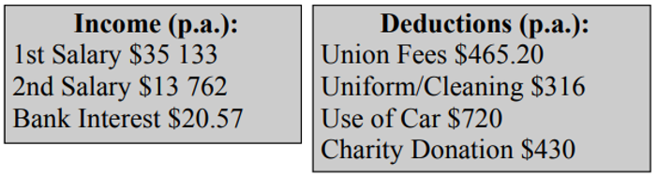
- Kate totalled her income and deductions for the year. Calculate:

  - Total gross income.
$48 915.57
  - Total allowable tax deductions.
$1931.20
  - Taxable income.
$46 984.37
  - Income tax payable.
$5736.92

- Sam earns $62 500 per year from his job, $500 interest from savings, and $850 from share dividends. He has allowable tax deductions of $1800 for a new laptop and $600 in union fees. Calculate:
  - Total gross income.
$63 850
  - Total allowable tax deductions.
$2400
  - Taxable income.
$61 450
  - Income tax payable.

$10 438.25
- Vivienne earns $122 400 per year from her job, $1500 interest from savings, and $2140 from share dividends. She has allowable tax deductions of $2900 for a comfy office chair and $4400 in other allowable tax deductions. Calculate:
  - Taxable income
$118 740
  - Income tax payable.

$29 057.50
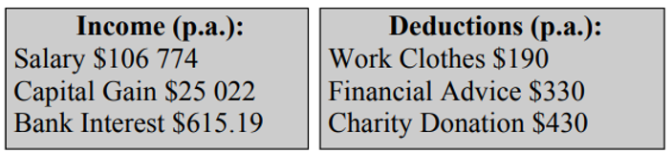
- Calculate tax payable from this table:

$131 461.19

Mastery
- Last year, Luke’s taxable income was $34 000.
This year, Luke’s taxable income has increased by $16 800.
How much extra money will Luke have this year, after paying tax, as a result of the increase in his taxable income?

$12 825
- Josh looked at the last row of the tax table and said ‘It is unfair that people in that tax bracket pay 45 cents of every dollar in tax’. Explain Josh’s misconception.

People only pay 45c per dollar for each extra dollar over $180, 000
- Use the tax table to complete this table
Taxable income | $0 | $18 200 | $45 000 | $120 000 | $180 000
Tax payable
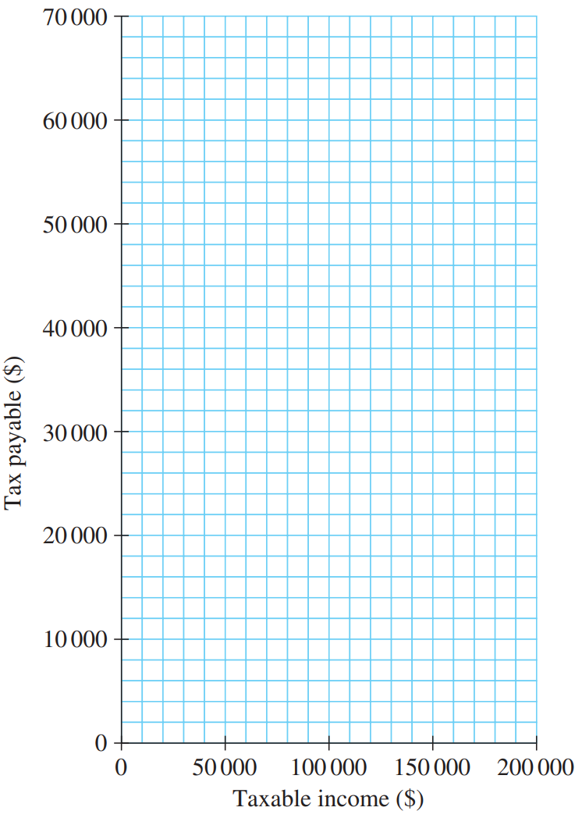
Plot the points on the axis and describe
the shape of the curve.

The graph gets steeper the more income you earn. The gradient represents the tax rate.
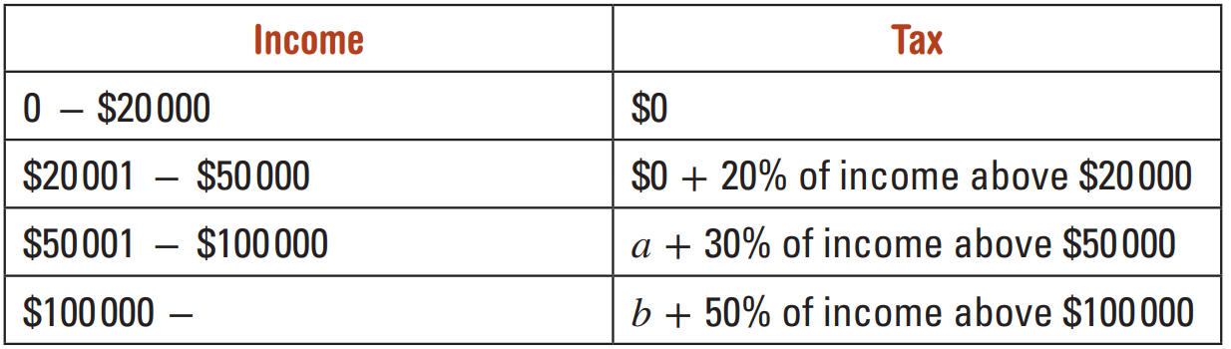
- The base tax is the sum of all the tax you pay in all the previous tax brackets.

Find the values of a and b in the above table.

a = $6000, b = $21 000
- 2021 HSC Standard 2 Band 4
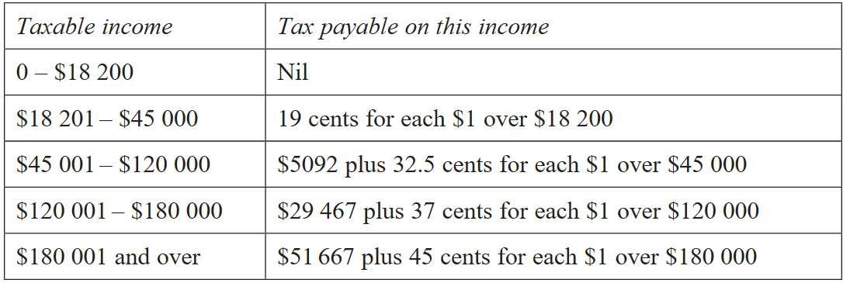
The table shows the income tax rates for the 2020-2021 financial year.

William has a gross annual salary of $84 000.
He has allowable tax deductions of $900 for home-office equipment and $474 for union fees.
Calculate the total tax payable by William.

$17 320.45

- 2023 HSC Standard 2 Band 5
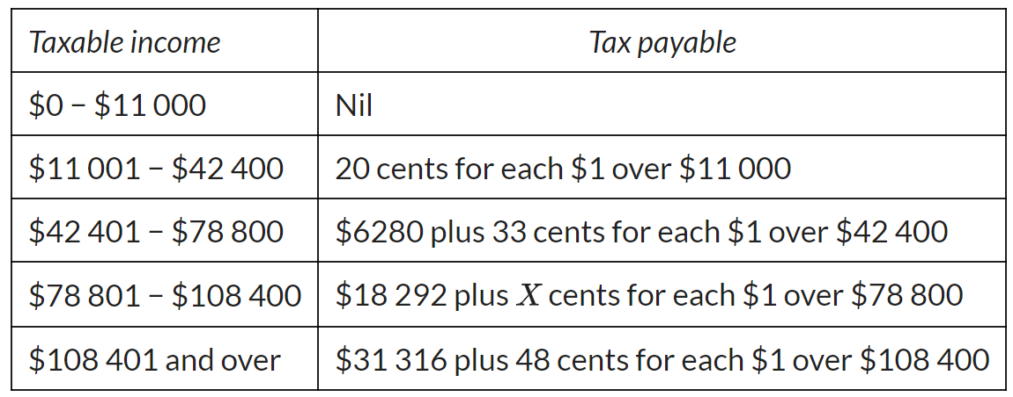
The table shows personal income tax rates for different taxable incomes for a particular country.

A person with a taxable income of $90 000 pays 25.8% of that income in tax.
What is the value of $X$ in the table?

44 cents
- The table shows personal income tax rates for a particular country.
Taxable income | Tax on this income
0–$21 000 | Nil
$21 001–$54 000 | 22c for each $1 over $21 000
$54 001–$95 000 | $11880 and 31c for each $1 over $54 000
$95 000+ | $\$ x$ and $y$ c for each $1 over $95 000
- Show that the value of $x$ is $24590.

- A person with a taxable income of $123 000 pays $36346.50 in tax.
Calculate the value of $y$ rounded to the nearest cent.

42 cents

Pay as You Go
- Pay as you go (PAYG) is how most people pay tax.
- Your employer deducts the tax out of from your pay over the year and sends it to the ATO.
- These PAYG deductions (or instalments) help you budget, avoiding a large year-end tax bill.

- Calculate tax payable. $Base tax+Tax rate×Excess$
- Calculate PAYG deductions per period. $Tax Payable÷Number of periods$
- Calculate net earnings per period. $Gross income per period-PAYG deductions per period$

Example Calculate PAYG tax to be deducted from pay.
Charlie has an income of $48 580.  Calculate his fortnightly net earnings after PAYG deductions.  Tax payable:  $5092+0.325×(48580-45000)$  $=\$6255.50$  Fortnightly PAYG instalment:  $\$6255.50÷26$  $=\$240.60$  Calculate his net earnings per fortnight.  $$Gross income/fortnight-PAYG/fortnight$$  $$=\frac{48580}{26}-240.60$$  $$=\$1627.86$$ | Hayley has an annual salary of $85 355.  Calculate tax payable.  $18207.38  Calculate her fortnightly PAYG instalments.  $700.28  Calculate her fortnightly net earnings.  $2582.60

Key ideas
- Income tax is …………………………………… (PAYG).
- This means the tax is …………………… from each of your payslips over time.

Foundation
- Calculate the PAYG deductions, given the tax payable and pay cycles.
- Annual tax payable: $22 825  Pay cycle: Fortnightly  $877.88 | - Annual tax payable: $12 820  Pay cycle: Fortnightly  $493.08
- Annual tax payable: $32 570  Pay cycle: Monthly  $2714.17 | - Annual tax payable: $8 828  Pay cycle: Weekly  $169.77

- Cherie has an annual salary of $82 355.
  - Calculate tax payable using the tax table.
$17 232.38
  - Calculate the weekly PAYG instalment.
$331.39
  - Calculate her weekly net earnings.
$1252.36

- Andrew has an annual salary of $134 559.
  - Calculate tax payable using the tax table.
$34 853.83
  - Calculate the fortnightly PAYG instalment.
$1340.53
  - Calculate his fortnightly net earnings.
$3834.82

- 2012 HSC Standard 2 Band 4
Tai earns a gross weekly wage of $1024.
Each week her deductions include tax instalments of $296.40, health fund contribution of $24.50, union fees of $15.80.
She also pays $3640 over the year as her share of the household expenses.
What percentage of her net wage does Tai pay for household expenses?

10.18%

Tax Refund or Liability
- Your taxable income may change due to extra income or allowable tax deductions
- This means your PAYG deductions might be off.
- At financial year-end, you lodge a tax return,
where you report additional income allowable tax deductions to adjust your tax bill.

$$Tax liability or refund = Total instalments-Tax payable$$

- If you pay too much tax, you get a tax refund, the government returns the extra.
- If you underpay, you have a tax liability. You owe the government money.

Example Calculate tax refund or tax liability.
Shirley has a tax payable of $30,000 and has already paid a total of $25,000 in instalments. Does she have a tax liability or refund, and by how much?  $25 000-30 000=-\$5000$  She has paid too little tax. Tax liability. | Nigel has paid a total of $1300 in tax throughout the year. He has a tax payable of $400. Does he have a tax liability of refund, and by how much?  $1300-400=\$900$  He has paid too much tax. Tax refund.

- David has a tax payable of $20,000 and has already paid a total of $15,000 in instalments. Does he have a tax liability or refund, and by how much?  Liability of $5000 | - Emily has a tax payable of $10,000 and has already paid a total of $17,000 in instalments. Does she have a tax liability or refund, and by how much?  Refund of $7000
- Frank has a tax payable of $5,000 and has already paid a total of $2,500 in instalments. Does he have a tax liability or refund, and by how much?  Liability of $2500 | - George has a tax payable of $0 and has already paid a total of $215 in instalments. Does he have a tax liability or refund, and by how much?  Refund of $215

Putting all Tax Calculations Together
- Calculate taxable income. $Gross income-allowable deductions$
- Calculate tax payable. $\left(Base tax\right)+\left(Tax rate\right)×\left(Taxable income -Upper limit of prev bracket\right)$
- Determine tax refund or liability. $Tax liability or refund=Total instalments-Tax payable$

Example Calculate tax refund or tax liability.
Worked Example | Your Turn
Sarah works as a secretary and earns a yearly salary of $34 479 plus an income of $1950 per year from baby-sitting. Her total tax deductions are $1570. During the year she paid tax instalments totalling $3265. Determine her tax refund or liability. | Charlie earned a salary of $73 000 from his main job and $8000 from side gigs. He has allowable tax deductions of $800. Over the year he has paid $26 000 in tax. Determine his tax refund or liability.
$Taxable income=\left(34479+1950\right)-1570$  $=34859$ | Taxable income
$Excess=34859-18200$  $=16659$  $Tax payable=0+16659×0.19$  $=3165.21$ | Excess  Tax payable
Refund/liability:  She has paid too much tax.  Tax refund of $3265-3165.21=\$99.79$ | Refund of $9468

Foundation
- Jenny has annual taxable income of $135 000.

  - Calculate her annual income tax payable.

$35 017
  - Determine her fortnightly tax instalments ………………………………………………………
$1346.81
- David has taxable income of $94 850.
  - Calculate his annual income tax payable.

$21 293.25
  - David has already paid $24 678 in tax throughout the year. Should he receive a tax refund or does he have a tax liability?

refund
- Luffy has annual taxable income of $19 864 with tax instalments paid over the year totalling $220.
  - Calculate his annual income tax payable.

$316.16
  - Should he receive a tax refund or does he have a tax liability?

liability
- Sarah works as a secretary and receives a yearly salary of $64 099 plus an income of $1950 per year from babysitting. Her total tax deductions are $1550. During the year she paid tax instalments totalling $3265.
  - Calculate her total income
$66 049
  - Calculate her taxable income
$64 499
  - Calculate her annual income tax payable.

$11 429.18
  - Should she receive a tax refund or does he have a tax liability?

liability

Development
- Charlie’s gross annual income is $155 730. His allowable tax deductions are $8230.
  - Calculate his taxable income.

$147 500
  - Calculate the amount of tax due.

$39 642
  - Charlie has paid tax instalments $860 per week. How much is this over the year?

$44 720
  - Will Charlie receive a tax refund or will he have to pay more tax?

refund
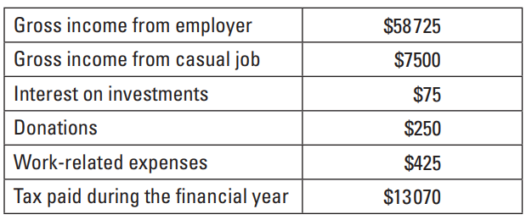
- Lee has come to the end of her first financial year as a teacher.
On 30 June she made the notes in the table to the right about the financial year.

  - Calculate Lee’s taxable income.
$65 625
  - Use the tax table to calculate Lee’s tax payable.

$11 795.13
  - Has Lee paid too much tax, or not enough? Calculate her refund or liability.

Too much. $1274.88 refund.
- Celine earns $32 056 per annum as an environmentalist and $8159 as a part-time analyst.
She has tax deductions of $4903 and has paid $5123.90 in tax instalments.
  - Find her taxable income.
$35 312
  - Find the income tax payable on her taxable income.

$3251.28
  - Find her tax refund or tax balance payable.

Tax refund of $1872.62

Mastery
- Mr Benton works part time and has a yearly salary of $29760.
He receives a salary of $2500 from his hobby of wood carving.
His tax deductions amount to $1090 and throughout the year he has paid PAYG instalments of $3215.90. Calculate his tax refund or liability.

Refund of $751.60
- Ricky earns $84 365 as a cabaret artist and $4620 from his share portfolio.
He has tax deductions of $13 884 and, throughout the year, pays a total of $15 988 in tax instalments.
Determine their tax refund or liability.

Refund of $1113.17
- Wally earned a gross annual income of $122 680. He had $2350 in tax deductions.
During the year, he paid $3000 per month in Pay As You Go (PAYG) tax.
Calculate his tax refund or liability.

Refund of $6410.
- Shirley makes $30 an hour and works 35 hours a week. She has tax deductions totalling $550. She has paid fortnightly tax instalments of $200. Calculate her tax refund or liability.

Liability of $2833.25

Medicare Levy
- Medicare is the Australian universal healthcare scheme. When you go to the doctor, the cost of the visit is either free, or the government will pay for a large percentage of the cost.
- The government partly gets its money from an additional tax called the Medicare levy.

Medicare Levy
$$Medicare Levy=2\%×Taxable Income$$
$$Total tax payable=Income tax payable+Medicare levy$$

Example Calculate Medicare Levy
Matthew earns an income of $76,000 annually. He has $1,000 of allowable deductions. Calculate his Medicare levy.  Taxable income $=76 000-1000$  $=75 000$  Medicare levy $=$ $2\%×Taxable Income$  $=0.02×75 000$  $=\$1500$ | Describe how we calculate taxable income.  …………………… $-$ ……………………………  Instead of multiplying by 2%, what decimal can we multiply by?  2% as a decimal is ……………  Does the Medicare levy percentage change according to income?

Calculate the Medicare levy:
- Taxable income of $85 490  $1709.80 | - Taxable income of $35 520  $710.40
- Gross income of $122 210, allowable deductions of $2800  $2388.20 | - Gross income of $140 625, allowable deductions of $828  $2795.94

Key ideas
- The Medicare levy is an additional tax of ………% of ……………………… income.

All Tax Calculations
- Calculate taxable income. $Gross income-allowable deductions$ (round down)
- Calculate income tax payable. $\left(Base tax\right)+\left(Tax rate\right)×\left(Excess\right)$
- Calculate Medicare levy. $2\%×Taxable income$
- Calculate total tax payable. $Income tax payable+Medicare levy$
- Determine tax liability or refund. $Total instalments-Tax payable$

Example Calculate tax refund or tax liability.
Worked Example | Your Turn
Joy has the following income and allowable tax deductions. She has paid PAYG instalments totalling $21500 over the year. | 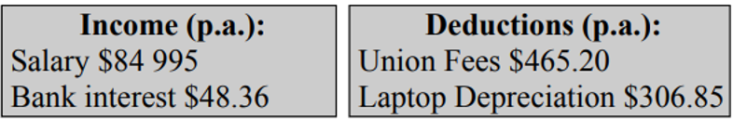  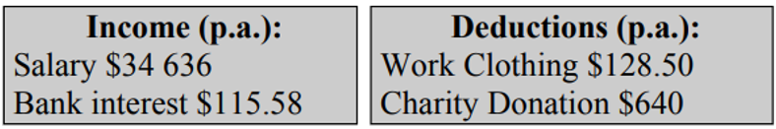  Patrick has the following income and allowable deductions. He has paid PAYG instalments totalling $8500 over the year.
Taxable income:  $Gross income-allowable deductions$  $=\left(84995+48.36\right)-(465.20+306.85)$  $=\$84271$ (rounded down to nearest dollar) | Taxable income:  $33983
Income tax payable:  $\left(Base tax\right)+\left(Tax rate\right)×\left(Excess\right)$  $=5092+0.325×\left(84271-45000\right)$  $=\$17855.08$ | Income tax payable:  $2998.77
Medicare levy:  $2\%×Taxable income$  $=0.02×84271$  $=\$1685.42$ | Medicare levy:  $679.66
Total tax payable:  $Income tax payable+Medicare levy$  $=\$17855.08+\$1685.42$  $=\$19540.50$ | Total tax payable:  $3678.43
Liability or refund:  $Total instalments-Tax payable$  $=21500-19540.50$  $=1959.50$ tax refund | Liability or refund:  Refund of $4821.57

Foundation
- Calculate the Medicare levy, given these annual taxable incomes.
- $88 420  $88 402 $×2\%=$ ………………  $1768.40 | - $35 290  $705.80
- $73 845  $1476.90 | - $192 920  $3858.40

- Calculate the Medicare levy, given the gross income and deductions.
- Income: $82 902  Deductions: $729  Taxable income: ……………………  $82 173  Medicare levy: ……………………  $1643.46 | - Income: $102 560, $29 120  Deductions: $1280  $2608.00
- Income: $292 560  Deductions: $3620, $825  $5762.30 | - Income: $169 490, $2100  Deductions: $7289, $621  $3273.60

- Calculate the income tax payable and Medicare levy. Add them to find the total tax payable.
The given numbers are annual taxable incomes.
- $57 821  Income tax payable:  $9258.83  Medicare levy:  $1156.42  Total tax payable:  $10 415.25 | - $29 700  $2779
- $104 200  $26 416 | - $224 690  $76 271.30
- Income: $65 020  Deductions: $7289  $10 384.20 | - Income: $92 126  Deductions: $4093  $20 838.39
- Mia works for a superannuation fund and receives a taxable income of $124 800.
  - Medicare levy is 2% of the taxable income. How much is Mia’s Medicare levy?

$2496
  - Calculate the total amount of tax due, including the Medicare levy.

$33 739
- Joshua earns $47 500 per year.
  - Calculate the amount of income tax he must pay.

$5904.50
  - Calculate the Medicare levy Joshua must pay.
$950
  - What is the total amount of tax Joshua must pay?

$6854.50
- Sam has a few odd jobs. In total, he earns $22 500 per year.
He has an allowable tax deduction of $2600. Calculate:
  - his taxable income
$19 900
  - the income tax payable on his taxable income

$323
  - the Medicare levy payable.
$398
  - the total tax payable.

$721
- Calculate the taxable income, given the Medicare levy.
- Oscar is a coach driver who paid a Medicare levy of $1193.40.  What was his taxable income?  $0.02x$ = 1193.40  $÷0.02 ÷0.02$  $x$ = ………………  $59 670 | - Felicia is an engineer who paid a Medicare levy of $6261.60.  What was her taxable income?  $313 080

Development
- Jenni earns a salary of $91 262 and claims a tax deduction of $1810.15 for work-related expenses.
  - Calculate Jenni’s taxable income.
$89 451.85
  - Calculate Jenni’s amount of tax payable.

$19 538.85
  - Calculate the amount of Jenni’s Medicare levy

$1789.04
- Find the tax payable, Medicare levy, determine the PAYG deductions per period, then calculate the net income per period.
- Annual income: $90 150  Pay cycle: Fortnightly  Medicare levy:  $1803  Tax payable:  $19 765.75  Total tax payable:  $21568.75  Fortnightly PAYG:  $829.57  Fortnightly net income:  $2637.74 | - Annual income: $55 890  Pay cycle: Fortnightly  Fortnightly net income: $1774.66
- Annual income: $145 280  Pay cycle: Weekly  Weekly net income: $1991.42 | - Annual income: $292 828  Pay cycle: Monthly  Monthly net income: $15 377.65

Mastery
- Catriona earns a salary of $87 210 and claims these deductions:
• Travel and entertainment expenses $650.25
• Depreciation of home computer $314.80
• Membership of a professional association $120.50
  - Calculate Catriona’s taxable income.
$86 124.45
  - Calculate Catriona’s income tax payable.

$18 457.45
  - What is the amount of Catriona’s Medicare levy?
$1722.49
  - what is Catriona’s total tax payable?
$20 179.94
  - If Catriona paid fortnightly PAYG instalments of $1006, does she have a tax liability or is she entitled to a tax refund?

Refund of $5976.06
- Gabby is an Australian resident who earned a yearly salary of $204 560.
She claimed tax deductions of $10 534 and paid a total of $72 156 PAYG tax.
Calculate her tax liability or refund, if she has to pay the Medicare levy.

Refund of $10 296.78
- Anand had a taxable income of $278 639 and paid $104 568 in PAYG tax over the year.
Find his tax liability or tax refund, if he needs to pay to Medicare levy.

Refund of $2940.67
- Liam earned a wage of $989.60 per week and paid PAYG tax of $229.02.
He was able to claim $38.25 per week in allowable tax deductions and $150 per year in donations.
Find his tax liability or tax refund, if he needs to pay to Medicare levy.

Refund of $4 426.57
- 2021 HSC Standard 2 Band 4
The table shows the income tax rates for the 2020-2021 financial year.

William has a gross annual salary of $84 000.
He has allowable tax deductions of $900 for home-office equipment and $474 for union fees.
William must also pay a Medicare Levy of 2% of his taxable income.
Calculate the total tax payable by William including the Medicare Levy.

$18 972.97
- 2018 HSC Standard 2 Band 4
Sabrina’s taxable income is $86 725 in a particular year.
The table below is used to calculate her tax payable.
In addition, she pays the Medicare levy, which is 2% of her taxable income.
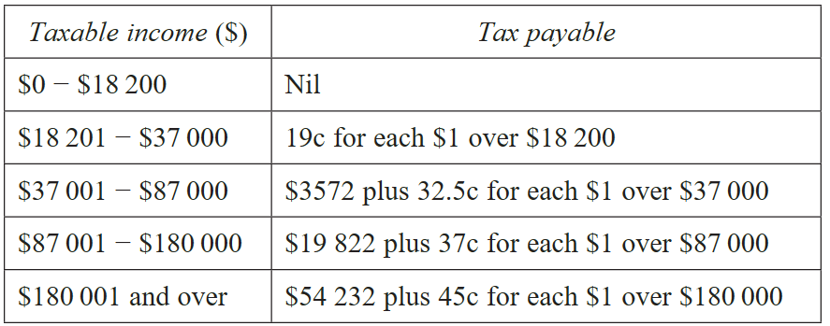

Calculate Sabrina’s net income in that year.

$65 257.87

- 2016 HSC Standard 2 Band 4
Theo is completing his tax return.
He has a gross salary of $82 521 and income from a rental property totalling $10 920.
He is claiming $13 420 in allowable deductions.
Determine Theo’s taxable income.

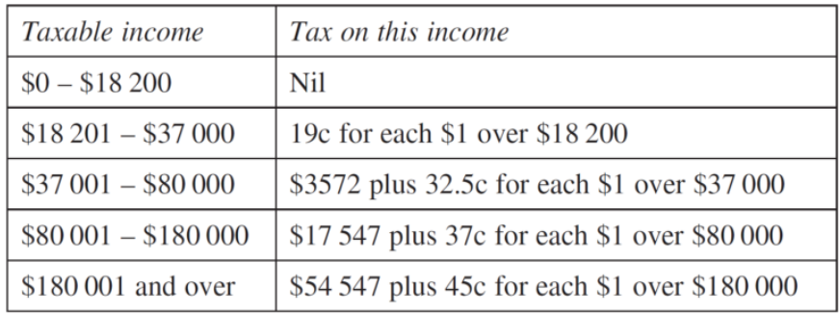
Using the tax table below, calculate Theo’s tax payable.

In addition to the above tax, Theo must also pay a Medicare levy of $1600.42.
Theo has already paid $20 525 as Pay as You Go (PAYG) tax.
Should Theo receive a tax refund, or will he owe more tax? Justify your answer.

Refund of $1369.81
- 2013 HSC Standard 2 Band 5
The table shows the tax payable to the Australian Taxation Office for different taxable incomes.
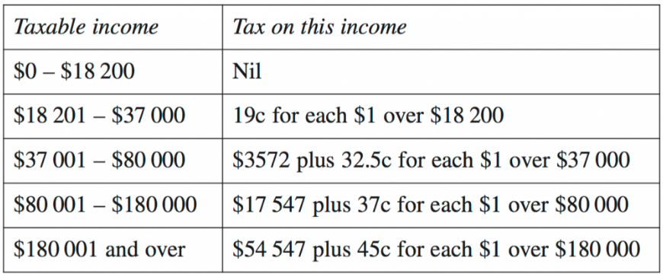

Peta has a gross annual salary of $84 000.
She has tax deductions of $1000 for work-related travel and $500 for stationery.
The Medicare levy that she pays is calculated at 1.5% of her taxable income.
Peta has already paid $18 500 in tax.
Will Peta receive a tax refund, or will she owe money to the Australian Taxation Office?
Justify your answer by calculating the refund or amount owed.

Liability of $1209.50

